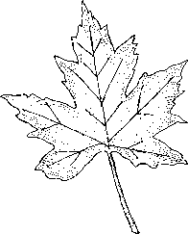
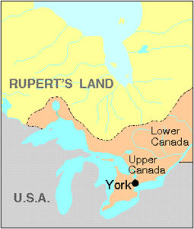
Turn Them Ooot!
#11
Mike Ford
from the album “Canada Needs You - vol. 1”
MapleMusicRecordings

Vocabulary!

- tract -

- corruption -

- decay –

- the boot –

- responsible government -

Do You Know It?

- Who was the “Family Compact”?
- Who were the “Tories”?
- Who is “William Lyon Mackenzie”?

What does the singer of the song want the people to do?

What is the singer’s occupation?

What does the singer think of the Family Compact?

What weapons do most of the rebels carry with them as they go to overtake Toronto (name changed from “York” in 1834)?

What is it that the singer hopes to gain by attacking the Family Compact?

Did You Catch It?

52

Do You Get It?
- Who is the “narrator” of this song? (no, I’m not talking about Mike Ford!)

- What does the singer try to entice the audience with in his speech?

- Where is this speech being given?

- What is the point of the “background voices/singers”?

- The men that fought in the Rebellions of 1837 and 1838 were willing to die for responsible government. If you were in their shoes, would you have fought? Why or why not?

Activities and Extensions

At what other points in Canadian history have people fought for “freedoms”? Which of these fights would you consider to be the most noble? Why?

Using a current issue in the news, write a similar type of speech to stir public outrage!

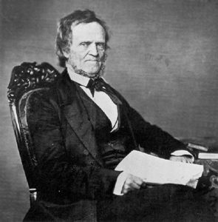
William Lyon Mackenzie is a controversial figure in Canadian history. Today, some people see him as a hero who fought for freedom and independence. Others consider him a troublemaker who only succeeded in delaying peaceful change. He was elected to the Assembly in 1828, but his harsh criticism of the Family Compact, a small group of men who controlled the colony, resulted in his repeated expulsion from the Assembly. However, his popularity with the voters resulted in a re-election each time. In 1834, Mackenzie became the first mayor of Toronto. By this time Mackenzie's views had become more extreme. In 1837 he led a rag-tag group of rebels down Yonge Street. Only a few shots were fired and the rebels scattered. He kept up his fiery criticism until the end.

Mackenzie's grandson, William Lyon Mackenzie King, became Prime Minister of Canada.



Teacher’s Guide

BACKGROUND INFORMATION

William Lyon Mackenzie is an exciting character in Canadian History that your class will enjoy. Mackenzie had a number of nicknames (Lil’ Mack, Firebrand, Muckraker, Lil’ Devil, etc.). He had a fiery temper and was known to throw his red wig at people during arguments! During the battle of with Sheriff Jarvis and his men (200 approx), Mack was wearing several overcoats buttoned up to his chin. He could hardly move with all these jackets, but he was convinced they made him bullet-proof! As night fell, Mack and his crew (700 approx) met the Sheriff and his men. The Sheriff’s men fired one volley and ran. Mack’s front line fired one volley and then hit the ground to reload. The rest of the rebels thought the front line had all been killed and ran. The main battle of the Rebellion of Upper Canada lasted less than a minute!

ANSWER KEY

“Do You Know It?”

- Appointed members of the Executive and Legislative Councils who held the bulk of the power in Upper Canada
- Mostly upper class conservatives who were opposed to responsible government
- A newspaper publisher who became a politician and revolutionary

“Did You Catch It?”

- He wants a revolution – for the people to rise up against the Family Compact
- He is a journalist
- He thinks that they are scum
- Most of the rebels were armed only with pitchforks
- He want to get responsible government

“Did You Get It?”

- The narrator is William Lyon Mackenzie
- He offers the other men: freedom, their own land, fair courts, paved roads, to roll up the rim at Timmies, protection from the Yankees
- The speech is given at a bar (Montgomery’s Tavern – where the rebels met “to get their courage up” before the big attack)
- The background voices show the men were a bit tipsy
- Answers will vary.

ADDITIONAL RESOURCES

Suggested Reading:
William Kilbourn, The Firebrand (1956);
James Reaney, The Boy with an R in His Hand: A Tale of the Type Riot at William Lyon Mackenzie's Print Office in 1826 (1984).
Will Ferguson, Canadian History for Dummies! (2001)

